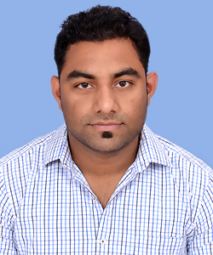
CV
Ashish Vats
Mobile number: +918608062541, +918826321222
Email address: vatsashish1990@gmail.com
Alternate Email address: vatsashish13@yahoo.com

Objective:
Aiming to achieve a challenging & successful career where I can make a significant contribution using my innovative ideas, knowledge, skills and experience with the objective of development & growth of the Organization.
Educational qualification:
Examination (year) | Institution | Board | Marks/Score
PG-DAC  (Post graduate Diploma in Advance Computing)  (February 2014 ) | Centre for Development of Advanced Computing (C-DAC,KP ,Bangalore) |  | Completed
B. Tech. (Information Technology )  (2008-2012) | Sunder Deep College of Engineering & Tech., Ghaziabad | GBTU | (76.5%)
12th (HSC) (2008) | Ghaziabad | CBSE | (63%)
10th (SSC) (2007) | Saharanpur | ICSE | (61%)

Work Experience:
- I worked at Cognizant Technology Solutions, Chennai as Programmer Analyst for 1 year. (June 2014- till date)
- I worked at HCL Infosystems Ltd. as TSO for 6 months (Aug 2012 to Jan 2013).

Experience Skills:
I have knowledge of .Net, C and MS SQL, Oracle SQL.
Computer skills:
- Efficient with respect to programming in .Net using Visual Studio 2010, 2013.
- Efficient with respect to programming in C.
- Have worked on VB6 code also.
- Have Java knowledge as well.
- Have working knowledge of MS Excel, MS Access.

Training, projects and workshops:

- Completed project on “Sunder Deep Placement Portal” year 2012.
- Practical Training at HCL CDC, Noida and completed my project, “ISPs of India” year 2010.
- Attended Seminar and workshop on Joomla year 2009.

Scholastic achievements:

- Cleared GATE 2013 from CS department.
- Member of Discipline Committee in College Fest year 2011.
- Awarded scholarship of INR 2000 for standing 3rd in class for the session 2010-11.
- Member of Anti Ragging Team year 2009.
- Sports: Shot-Put Winner in Intra School Athletic Meet year 2006
- A-certificate & Inter Group Competition (Winner) Certificates in NCC year 2005.

Personal details:

Name : | Ashish Vats
Date of Birth : | 13th Jan 1991
Father’s name : | Sh. Hari Prakash Vats
Mother’s name : | Smt. Manju Vats
Correspondence Address : | Q4 Oak Tree Apartment, Kazhipattur, Kanchipuram, TN. 603103
Permanent Address : | I-239 Govind Puram, Ghaziabad, UP, 201013
Passport number : | J8656174
Hobbies and other interest : | Playing & watching Cricket, listening to music, making friends.

Signature:
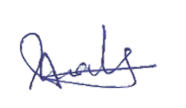

(ASHISH VATS)

